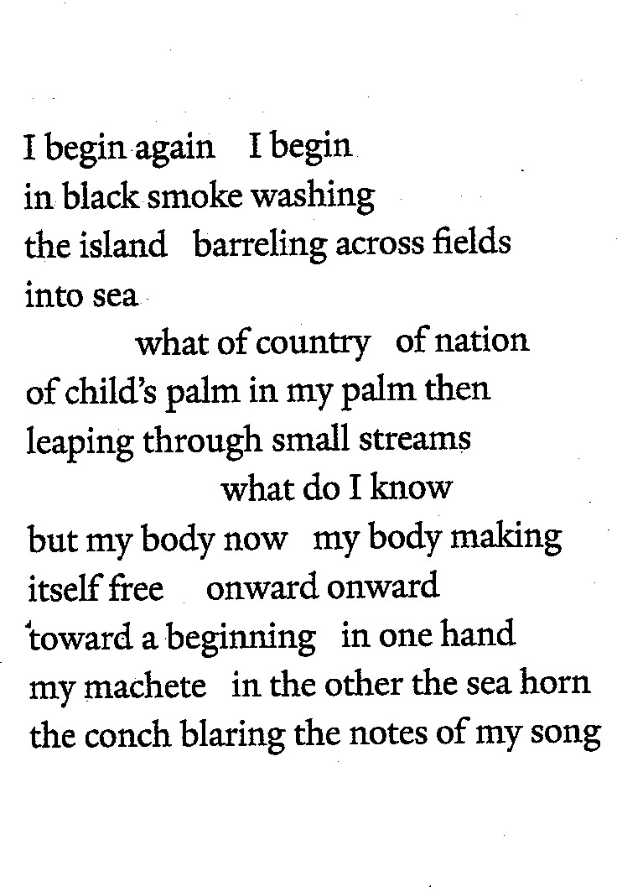

Chant for the Waters and Dirt and Blade excerpt Desiree C Bailey