 FOR IMMEDIATE RELEASE
August 2006
Heidi Simonian: 323 857-6515, hsimonian@lacma.org
Allison Agsten: 323 857-6543, aagsten@lacma.org

LACMA RECEIVES SIGNIFICANT TIBETAN AND NEPALESE ARTWORKS
FROM OSCAR-WINNING ACTOR JAMES COBURN AND HIS WIFE PAULA

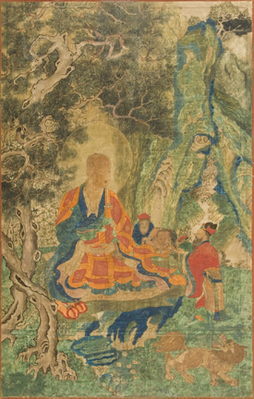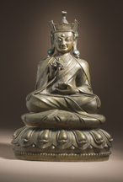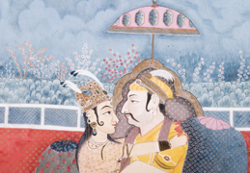
(Left) The Arhat Kanakabharadhvaja, Eastern Tibet, Kham region, c. 17th century, Gift of the James and Paula Coburn Foundation
(Center) Padmasambhava (Guru Rinpoche, 8th century), Tibet, Tsang Valley, 15th–16th century, Gift of the James and Paula Coburn Foundation
(Right) Emperor Jahangir (r. 1605–27) and Empress Nur Jahan in Union (Detail), Nepal, c. 1830, Gift of the James and Paula Coburn Foundation

Los Angeles–The Los Angeles County Museum of Art (LACMA) is pleased to announce the generous bequest of eleven Asian objects from The James and Paula Coburn Foundation, the estate of the late well-known actor and long-time LACMA supporter James Coburn (1928–2002), and his wife and actress Paula Coburn (1955–2004). The gift features various works from Tibet, including a Buddhist sculpture and six important religious paintings (called thangkas) made in a Chinese-Tibetan style, as well as four Nepalese opaque watercolor portraits. All of these paintings are the first examples of their kind to enter LACMA’s holdings. The Tibetan paintings, along with a number of previous donations by Mr. Coburn, are currently on view in LACMA’s South and Southeast Asian Art galleries.

The Coburns’ thangka paintings fill a gap in LACMA’s renowned collection of Tibetan art. They were created in Kham, an area of eastern Tibet that borders China, and epitomize the region’s hybrid artistic tradition heavily influenced by Chinese figural and landscape conventions. Five of the paintings portray Arhats (Enlightened Buddhist teachers), while the sixth depicts the Lokapalas (World Guardians), who were typically included in sets of Arhat paintings. Also from Tibet is a bronze sculpture of the revered Buddhist teacher Padmasambhava (717–775), featuring jewelry inlaid with turquoise and elegant textile designs.

The Nepalese paintings are symbolic portraits of earlier South Asian monarchs. The paintings date from the early nineteenth century, and are executed in a style derived from Indian painting. They were once part of a larger series of paintings presumably commissioned by the Nepalese king, Rajendra Bikram Shah (reigned 1816–47). A portrait of the king with his queen was included in the original set, suggesting that its symbolic purpose was to equate the king with the great rulers of the past.
Throughout his extensive career, Mr. Coburn played the “tough guy” or villain in several critically acclaimed movies and received an Academy Award for Best Supporting Actor in Affliction (1997). He was a steadfast supporter of LACMA who donated numerous Himalayan, and South and Southeast Asian works, and also narrated the video for LACMA’s 1994 exhibition, The Peaceful Liberators: Jain Art from India. Together, Mr. and Mrs. Coburn shared a passion for Asian art and furthering arts education.

About the South and Southeast Asian Art Collection
LACMA’s collection features one of the largest and most comprehensive collections of South and Southeast Asian art in the Western Hemisphere. Its holdings of Himalayan are particularly noteworthy, and include many of the finest and earliest Tibetan and Nepalese works of art. The museum’s world-class collection also contains numerous high quality objects from India, Pakistan, Bangladesh, Sri Lanka, Cambodia, Thailand, Vietnam, Myanmar (Burma), and Indonesia.

About LACMA
LACMA has assembled a permanent collection that includes approximately 100,000 works spanning the history of art from ancient times to the present, making it the premier encyclopedic visual arts museum in the western United States. The museum uses its collection and resources to provide a variety of educational and cultural experiences for the people who live in, work in, and visit Los Angeles. LACMA offers an outstanding schedule of special exhibitions, as well as lectures, classes, family activities, film programs, and world-class musical events.

####

