

FOR IMMEDIATE RELEASE
December 2006
Allison Agsten: 323 857-6543, aagsten@lacma.org
Heidi Simonian: 323 857-6515, hsimonian@lacma.org

LACMA RECEIVES MAJOR AMERICAN REALIST PAINTING
Thomas Eakins’s Wrestlers Joins LACMA’s Sketch of the Painting

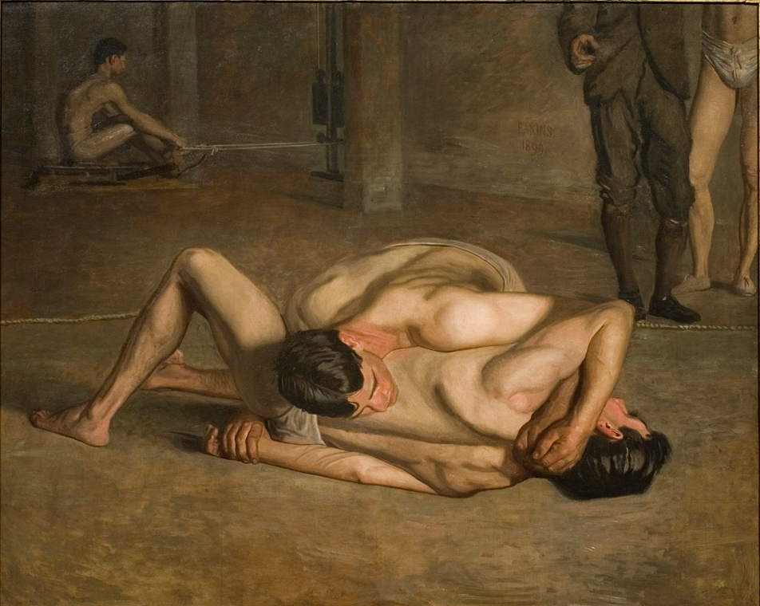
Thomas Eakins (United States, 1844-1916), Wrestlers, 1899,
oil on canvas, 62 x 72 in., Gift of Cecile C. Bartman and
The Cecile and Fred Bartman Foundation

Los Angeles—The Los Angeles County Museum of Art (LACMA) announced today the recent acquisition of Thomas Eakins’s (1844 – 1916) large sporting painting, Wrestlers (1899). The generous gift of Mrs. Cecile C. Bartman and The Cecile and Fred Bartman Foundation, Wrestlers is one of the last major subject paintings this great American realist created. Viewed in the trajectory of Eakins’s accomplishments, from his first student studies of the figure and early rowing pictures of the 1870s to his late boxing and wrestling paintings, Wrestlers stands as a superb summation of some of the most significant themes of the artist’s career. Mrs. Bartman explained her gift, “LACMA has been a significant part of my life ever since I moved from Chicago, and the eighteen years I served as a docent were quite enjoyable. I thought it was time to give something back to this great institution.” And Michael Govan, LACMA’s CEO and Wallis Annenberg Director, noted, “Wrestlers is one of the most historically significant additions to the museum’s encyclopedic permanent collection, which already includes the preparatory sketch of this powerful painting. Prominently situated in the canon of American Art, Wrestlers will always hold an important place in our galleries as well.”

Thomas Eakins, alongside Winslow Homer, is considered one of the two greatest realists of American painting of the nineteenth century. While Homer concentrated on rural themes, and ultimately on the relationship of humanity to nature, Eakins focused on people. He was a determined materialist, and though he was a portrait painter of great psychological depth, his primary focus was the body, the human being embodied in his or her physical reality. He was also a beloved yet controversial academic teacher, proselytizing drawing from the live model and the study of anatomy. As such, he stands as the first American artist to base his art on the close and exacting analysis of the body, and is the fountainhead for a realist tradition which extends from him through Robert Henri and the Ashcan School to Reginald Marsh, Fairfield Porter, Philip Pearlstein, and California artist David Park. Eakins’s deep conviction that the human is the central concern of painting, and that the human is composed indissolubly of mind and body, is what made him influential to his younger colleagues and later generations. Wrestlers is Eakins last completed statement on the subject and is a testament to a lifetime of teaching, painting, and struggling with the dilemmas of representing the body.

In this vein, Wrestlers is also very much a spiritual self-portrait of a frustrated artist towards the end of his career. Although the focus on two nude figures underscores Eakins’s academic training, which extolled and elevated the human body in its most perfect state, the unusual composition suggests that the artist intended the painting to be much more than a literal representation of a new popular bourgeois spectator entertainment. In Eakins’s best and most modern late paintings, the artist compelled the viewer to look again and think again about what is presented. Often the general effect for the viewer of the most probing late paintings is a feeling of discomfort. This was intentional as Eakins himself was in the midst of many personal, familial, and professional problems. The unresolved issues of Wrestlers thereby become echoes of Eakins’s own life.

About the department
The American Art department is one of the oldest curatorial departments of LACMA and is focused on historical American painting and sculpture from the eighteenth century through the 1950s. Its collection includes some of the most significant icons in the art history of the United States, among them Mary Cassatt’s first dated mother and child painting, John Singer Sargent’s largest American portrait, Mrs. Edward Davis and her Son Livingston, and George Bellows’s famous urban scene, Cliff Dwellers.

About LACMA

In April 2006, Michael Govan became CEO and Wallis Annenberg Director of the Los Angeles County Museum of Art (LACMA). He is the seventh person to hold the position of Director in the museum’s 41-year history. Established as an independent institution in 1965, the Los Angeles County Museum of Art has assembled a permanent collection that includes approximately 100,000 works of art spanning the history of art from ancient times to the present, making it the premier encyclopedic visual arts museum in the western United States. Located in the heart of one of the most culturally diverse cities in the world, the museum uses its collection and resources to provide a variety of educational and cultural experiences for the people who live in, work in, and visit Los Angeles. LACMA offers an outstanding schedule of special exhibitions, as well as lectures, classes, family activities, film programs, and world-class musical events. The museum offers free admission after 5 pm every day the museum is open and all day on the second Tuesday of each month. LACMA's “Free after Five” program is sponsored by Target.

General Information: LACMA is located at 5905 Wilshire Boulevard, Los Angeles CA, 90036. For more information about LACMA and its programming, call (323) 857-6000 or log on to www.lacma.org.

Museum Hours and Admission: Monday, Tuesday, and Thursday, noon–8 pm; Friday, noon–9 pm; Saturday and Sunday, 11 am–8 pm; closed Wednesday. Adults $9; students 18+ with ID and senior citizens 62+ $5; children 17 and under are admitted free. Admission (except to specially ticketed exhibitions) is free the second Tuesday of every month, and every evening after 5 pm.

# # #

