
FOR IMMEDIATE RELEASE
July 2007
Allison Agsten: 323 857-6543, aagsten@lacma.org
Heidi Simonian: 323 857-6515, hsimonian@lacma.org

BELLOWS ACQUISITION UNDERSCORES GROWING PROMINENCE OF
LACMA’S AMERICAN ART DEPARTMENT
Raymond J. and Margaret Horowitz Give Large-Scale Portrait to the Museum
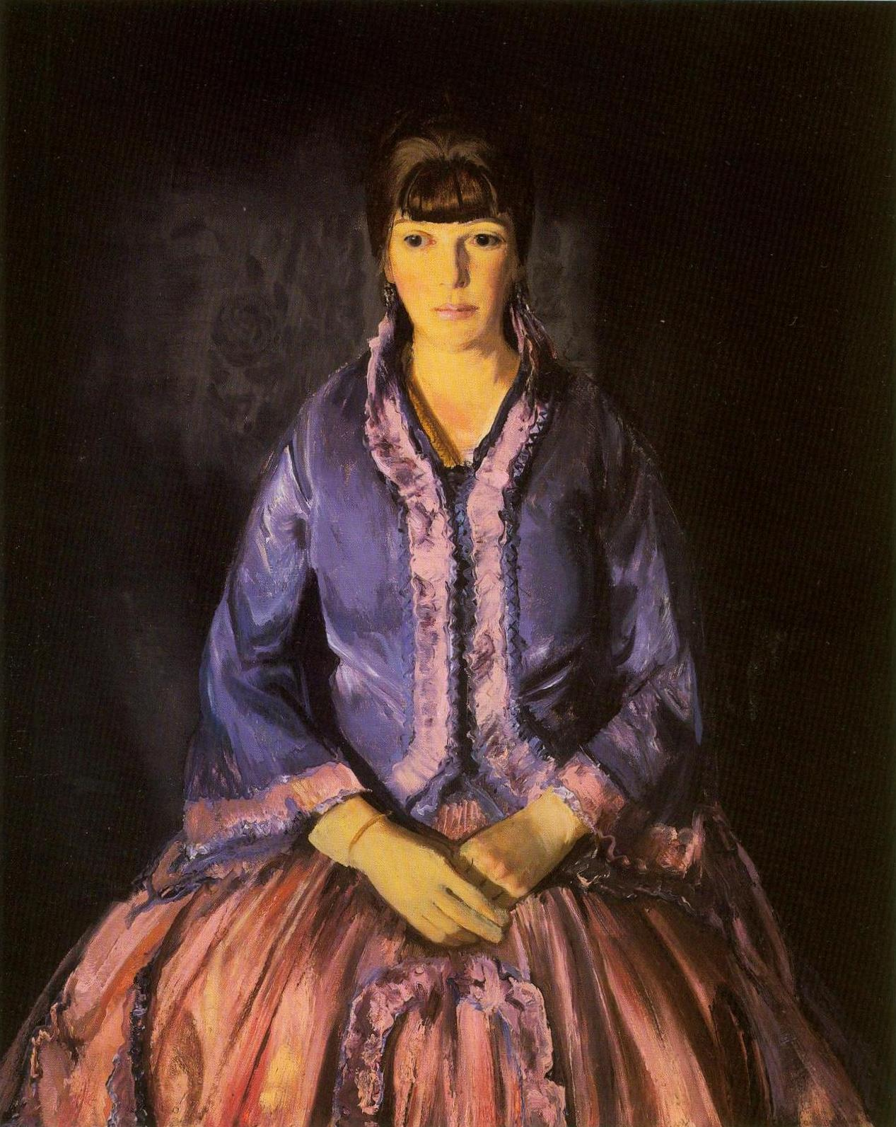
George Bellows, Emma in the Purple Dress, 1919, oil on panel, 40 x 32 in.
Gift of Raymond J. and Margaret Horowitz, © 2007 Museum Associates/LACMA

Los Angeles—The Los Angeles County Museum of Art (LACMA) announced today the acquistion of George Bellows’s (American, 1882–1925) landmark painting, Emma in the Purple Dress (1919). This, a commanding depiction of Bellows’s wife, reflects the artist’s markedly changed approach to portraiture in which exacting compositional geometry became a key element. The painting is currently on view and is hung opposite one of Bellows’s—and the museum’s—most recognizable and iconic works, Cliff Dwellers.

Emma in the Purple Dress is the generous gift of Raymond J. and Margaret Horowitz, both now deceased. In 1993, they established the Margaret and Raymond Horowitz Foundation to promote quality American painting throughout the country with their donations. As pioneer collectors, they amassed an impressive cadre of works that focused on the American masters of impressionism and realism during the Gilded Age. The collection of these well known benefactors was shown twice over the years, once at The Metropolitan Museum of Art, where the Horowitz’s were active, and also at the National Gallery of Art in Washington, D.C.

With the donation of Emma in the Purple Dress, LACMA’s collection of Bellows’ works documents the artist’s entire range of subject matter: urban genre, portraiture, and landscape. In addition, the newly acquired painting also augments a notable area of expertise within the museum. Michael Govan, LACMA CEO and Wallis Annenberg Director said, “The gift of Emma in the Purple Dress, coupled with the donation of Thomas Eakins’s Wrestlers six months ago, underscores the growing prominence of LACMA’s American Art Department. We’re deeply grateful to the Margaret and Raymond J. Horowitz Foundation for bestowing such an outstanding and complementary painting to our permanent collection.”

Speaking on behalf of the Margaret and Raymond Horowitz Foundation, Warren Adelson noted, “We are pleased to extend the rich tradition of giving that the Horowitz’s established long ago. It’s thrilling to see the powerful work Emma in the Purple Dress in such a perfectly-suited location as LACMA. Judy Horowitz Babcock, our fellow board member, is a long-time resident of Santa Barbara, and she is especially pleased to see this masterwork from her parents' collection in California.”

George Bellows was one of the foremost early twentieth-century realists in American art, most often identified with the Ashcan school of painting. Although the vivacity of his surfaces and the liveliness of many of his subjects often suggest that his painting was a matter of complete spontaneity, the opposite was true. In his mature work, such as the portrait of his wife, Emma in the Purple Dress, Bellows demonstrated a rational and systematic approach that was often based on compositional systems and color theories.

About the Department
The American Art Department is one of the oldest curatorial departments of LACMA and is focused on historical American painting and sculpture from the eighteenth century through the 1950s. The newly reinstalled collection includes significant icons in the history of United States art, among them Mary Cassatt’s first dated mother and child painting, John Singer Sargent’s life-size, technical tour-de-force Mrs. Edward Davis and her Son Livingston, the recently acquired Thomas Eakins painting, Wrestlers, and George Bellows’s famous urban scene, Cliff Dwellers.

About LACMA
LACMA—the largest encyclopedic museum in the Western United States—is the only museum of its kind to make contemporary art a principal area of activity with the opening of the Broad Contemporary Art Museum (BCAM). The Renzo Piano-designed BCAM is a cornerstone of the museum’s ten-year project to dramatically renovate and expand LACMA’s twenty-acre campus. This evolving contemporary collection, coupled with the museum’s robust permanent collection of more than 100,000 works spanning the history of art and extensive free public programming, make LACMA the definitive cultural town square for the city of Los Angeles and its visitors.

General Information: LACMA is located at 5905 Wilshire Boulevard, Los Angeles CA, 90036. For more information about LACMA and its programming, call (323) 857-6000 or log on to www.lacma.org.

Museum Hours and Admission: Monday, Tuesday, and Thursday, noon–8 pm; Friday, noon–9 pm; Saturday and Sunday, 11 am–8 pm; closed Wednesday. Adults $9; students 18+ with ID and senior citizens 62+ $5; children 17 and under are admitted free. Admission (except to specially ticketed exhibitions) is free the second Tuesday of every month, and every evening after 5 pm.

# # #

