
FOR IMMEDIATE RELEASE
July 25, 2007
Christine Choi: 323 932-5883, cchoi@lacma.org
Allison Agsten: 323 857-6543, aagsten@lacma.org

LACMA ACQUIRES RARE OLD MASTER PAINTING
NEVER VIEWED PUBLICLY UNTIL NOW
Ahmanson Foundation Funds Significant Addition to Museum’s Renowned European Collection
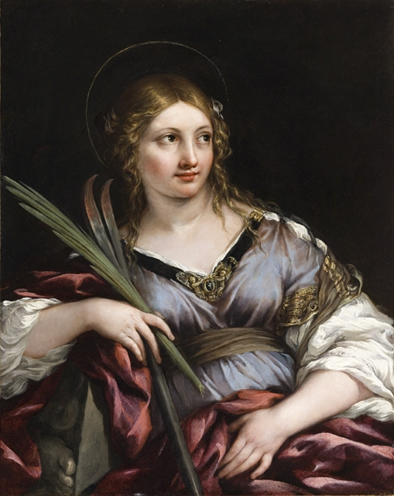

Pietro da Cortona, St. Martina, ca. 1635–40, oil on canvas, 37 1/2 x 30 in.
Gift of The Ahmanson Foundation, photo © 2007 Museum Associates/ LACMA

Los Angeles—The Los Angeles County Museum of Art (LACMA) announced today the acquisition of Pietro da Cortona’s (Italy, 1596–1669) painting, St. Martina (c. 1635–40). Hidden in a private British collection for 160 years, the elegant portrait of the Roman martyr saint has never been publicly exhibited. The rediscovery of St. Martina—created by one of the foremost artists of the Roman Baroque period—is particularly extraordinary since works by Pietro da Cortona have generally been absent from the art market for decades. The painting is on view in the Thornton Gallery (Second Floor) of the Ahmanson Building at LACMA.
Unknown to Cortona scholars until recently, St. Martina has never been exhibited or published. Its subject, however, was one intimately familiar to the artist, as the young Roman martyr frequently appeared in his work. An architect as well as a painter, he designed the church dedicated to the saint in the Roman Forum, executed a famous altarpiece depicting her martyrdom for the Siena Cathedral, and executed compositions in which the saint appears, such as The Madonna and Child with Saint Martina (c. 1645), acquired in 1984 by the Kimbell Art Museum, Fort Worth. Other paintings by Cortona may be found in such museums as The Metropolitan Museum of Art in New York and Ringling Art Museum in Sarasota, but his work remains rare in United States museums.
St. Martina is the most generous gift The Ahmanson Foundation has ever made to LACMA. The foundation has continually supported LACMA’s Department of European Painting and Sculpture, enabling it to expand the museum’s world-class collection of Old Master paintings and sculptures. Michael Govan, LACMA CEO and Wallis Annenberg Director said, “The Ahmanson Foundation has been the most consistent and generous donor to the museum in its history. Over the years, it has been through their support that the museum has been able to add masterworks by such artists as Guido Reni, Jan Steen, and Claude Lorrain—which have been for many years the core of LACMA’s collection.” In addition to St. Martina, the foundation recently funded two other significant acquisitions—a rare Renaissance statue by Santi Buglioni, San Giovanni di Capistrano, and a powerful painting by Jacques-Louis David, Portrait of Jean-Pierre Delahaye.
Pietro da Cortona was a prominent artist and architect of the Roman Baroque period. A protégé of three Popes, Urban VIII, Alexander VII and Innocent X, he was also the official painter for a number of the wealthiest families in seventeeth-century Rome. To this day, Cortona's fresco ceiling in the Grand Salon of the Palazzo Barberini (now the Galleria d'Arte Antica), painted in 1635, remains a major attraction in Rome. A masterpiece of illusion, this allegory of the Barberini family does not only demonstrate the artist's dexterity at organizing a complex composition, but also displays Cortona's mastery of drawing and his use of brilliant colors.
About European Painting and Sculpture at LACMA
LACMA’s collection of European paintings and sculpture covers all major styles and artistic movements in the history of European art from the twelfth to the early-twentieth centuries. The collection is especially renowned for its outstanding representation of Italian baroque, Dutch painting of the Golden Age, and eighteenth-century French, along with significant holdings in sculptures from all ages.
Among the many masterpieces in LACMA’s European collections are world-famous paintings and sculptures, such as Georges de La Tour’s Magdalen with the Smoking Flame (c.1638–40), Rembrandt van Rijn’s Raising of Lazarus (c.1630), Edgar Degas’s The Bellelli Sisters (1862–64), Paul Cézanne’s Sous-Bois (1894), and Jean-Antoine Houdon’s Voltaire (c. 1779–1795).
About LACMA
LACMA—the largest encyclopedic museum in the Western United States—is the only museum of its kind to make contemporary art a principal area of activity with the opening of the Broad Contemporary Art Museum (BCAM). The Renzo Piano-designed BCAM is a cornerstone of the museum’s ten-year project to dramatically renovate and expand LACMA’s twenty-acre campus. This evolving contemporary collection, coupled with the museum’s robust permanent collection of more than 100,000 works spanning the history of art and extensive free public programming, make LACMA the definitive cultural town square for the city of Los Angeles and its visitors.

General Information: LACMA is located at 5905 Wilshire Boulevard, Los Angeles CA, 90036. For more information about LACMA and its programming, call (323) 857-6000 or log on to www.lacma.org.

Museum Hours and Admission: Monday, Tuesday, and Thursday, noon–8 pm; Friday, noon–9 pm; Saturday and Sunday, 11 am–8 pm; closed Wednesday. Adults $9; students 18+ with ID and senior citizens 62+ $5; children 17 and under are admitted free. Admission (except to specially ticketed exhibitions) is free the second Tuesday of every month, and every evening after 5 pm.

# # #

